Brady Heinz 5.2 Assignment 2/8/2026
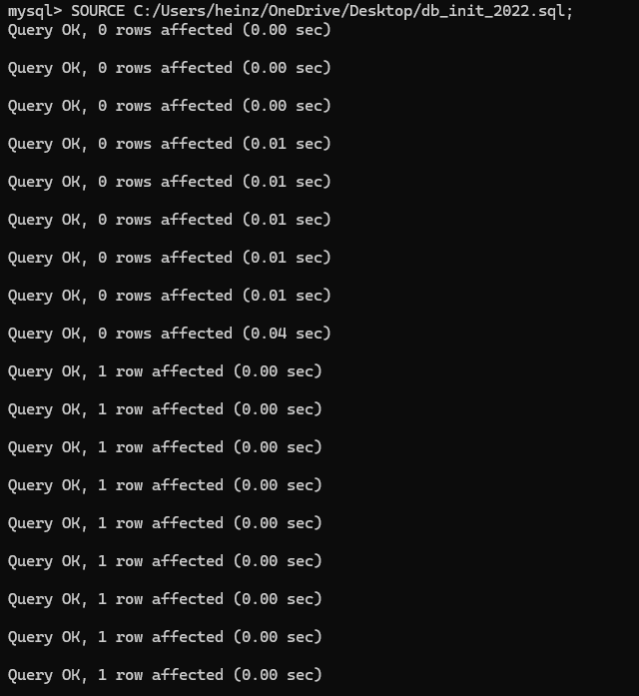

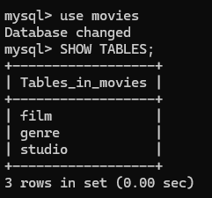

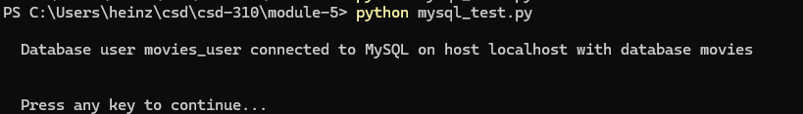

https://github.com/heinzbrady/csd-310

